# Aqua Multifocal

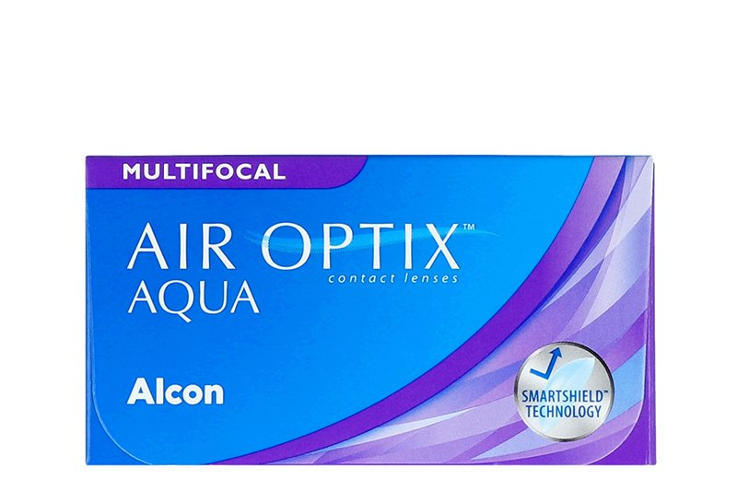

Product information

|  |  |
| --- | --- |
| **Brands** | Air Optix |
| **Availability** | While supplies last. This product is being discontinued by the manufacturer. |
| **Replacement** | Monthly |
| **Material** | 67% lotrafilcon B polymer, 33% H2O |

Description

**AIR OPTIX® AQUA MULTIFOCAL lenses, you have a new option for clear vision at all distances. From reading, to working on a computer, to driving, AIR OPTIX® AQUA MULTIFOCAL lenses provide smooth transitions as your eyes naturally move from one focal distance to another – near, intermediate and far.  
  
With doctor's approval, the Air Optix Aqua Multifocal can be worn as an extended wear lens (up to 6 nights).  
  
*Limited time offer. While supplies last. Only on your Air Optix Aqua Multifocal order on this website. Discount applied on the current website price at the time of order. Cannot be combined with any other offers. Promotions are subject to change without notice. We reserve the right to cancel orders that are in breach of the terms and conditions of this offer.**